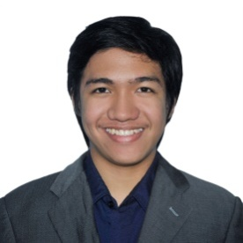QYLE JOHN DLA. SAN JUAN

SOFTWARE DEVELOPER

Naga City, Camarines Sur

Philippines

+639357897878

qylesanjuan@gmail.com

|  |
| --- |
| OBJECTIVES |
| To meet people of different nationality and culture  To share our culture and my experience to the international community  To learn from the conclave about entrepreneurship, leadership, and technology |

|  |  |
| --- | --- |
| EDUCATION | SEMINARS/CONFERENCES |
| COLLEGE  Bachelor of Science in Computer Science  University of the Philippines Los Baños  2012-2016  *Cum laude*  SCHOLARSHIP  Department of Science and Technology  RA 7687 Scholarship  AFFILIATION  Young Software Engineers’ Society  Human Resources Department Head  2015-2016  UNDERGRADUATE TRAINING  OOCL Philippines  Software Developer  June 2015 – July 2015  WORK EXPERIENCE  Student Assistant  University of the Philippines Los Baños  New Dormitory | **Android Meetup at UPLB**  **by Google Students Group**  University of the Philippines Los Baños  November 10, 2014  **UX Philippines Conference**  De La Salle University Manila  November 15, 2014  **Asia Pacific Student Leaders’ Forum**  National University of Singapore  June 8 – 10, 2015  **Google I/O Extended Manila**  De La Salle University Manila  July 11, 2015  **Startup Weekend Los Baños**  University of the Philippines Los Baños  April 15-17, 2016 |